**Logical Modelling and Normalisation Woody**

**Lab 11.1**

1. **Schema**

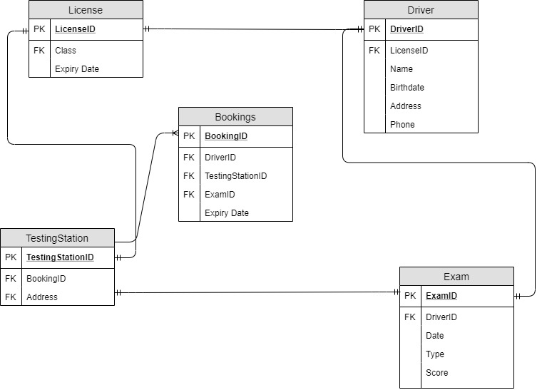

1. **Data Dictionary**

|  |  |  |  |
| --- | --- | --- | --- |
| Name: Licence | Description | Data Type | Constraint  PK  /FK |
| **License** | Holds information about the License |  |  |
| LicenseID | Identifies license ID | Int | PK |
| Class | Identifies license class | Varchar | FK |
| ExpiryDate | Identifies expiry date | Number |  |

|  |  |  |  |
| --- | --- | --- | --- |
| Name: Driver | Description | Data Type | Constraint  PK  /FK |
| Driver | Information about the driver |  |  |
| DriverID | Identifies driver ID | Int | PK |
| LicenseID | Identifies license ID | Int | FK |
| Name | Identifies Driver’s name | Varchar |  |
| Birthdate | Identifies Driver’s birthdate | Date |  |
| Address | Identifies Driver’s address | Varchar |  |
| Phone | Identifies Driver’s phone number | Number |  |

|  |  |  |  |
| --- | --- | --- | --- |
| Name: TestingStation | Description | Data Type | Constraint  PK  /FK |
| **TestingStation** | Testing Station information |  |  |
| TestingStationID | Identifies testing station ID | Int | PK |
| BookingID | Identifies license address | Int | FK |
| Address | Identifies testing station address | Varchar |  |

|  |  |  |  |
| --- | --- | --- | --- |
| Name: Exam | Description | Data Type | Constraint  PK  /FK |
| **Exam** | Testing Station information |  |  |
| ExamID | Identifies testing ID | Int | PK |
| DriverID | Identifies testing station ID | Int | FK |
| Date | Identifies exam date | Number |  |
| Type | Identifies exam type | Varchar |  |
| Score | Identifies exam score | Int |  |

|  |  |  |  |
| --- | --- | --- | --- |
| Name: Bookings | Description | Data Type | Constraint  PK  /FK |
| **Bookings** | Testing Station information |  |  |
| BookingID | Identifies license booking ID | Int | PK |
| DriverID | Identifies testing station ID | Int | FK |
| ExamID | Identifies testing ID | Int | FK |
| TestingStationID | Identifies testing station ID | Int | FK |

